MECHANICS-1
Q1 A man travels along a straight road for the first half length with a speed u and the second half with a speed v .Then the average speed is given by:
- Zero
Q2 Motion of a particle can be described in x-direction by x = a sin wt and y-direction by y = b cos wt. The particle is moving on [NDA -2013 II]
a) a circular path of radius a
b) a circular path of radius b
c) an elliptical path
d) a straight line
Q3 When a ball A is thrown horizontally and another ball B is dropped from the top of the cliff , which will be reach ground first.
- A will reach ground first
- B will reach ground first
- Both will reach ground at same time
- Given data not enough
Q4 A staircase has five steps each 10 cm high and 10 cm wide. What is the minimum horizontal velocity to be given to the ball so that it hits directly the lowest plane from the top of staircase [NDA -2012II]
- 2m/s
- 1m/s
- m/s
- ½ m/s
Q5 Area between speed - time graph and time axis gives :
- Distance
- Velocity
- Speed
- None of these
Q6 An object undergoes an acceleration of 8 m/s² starting from rest. Distance travelled in 1 s is :
- 2m
- 4m
- 6m
- 8m
Q7 The velocity-time graph of a body moving in a straight line is shown in figure. The distance travelled by the body in 6 seconds is.
- 10m
- 12m
- 8m
- None of these
Q8 Velocity-time graph AB (Figure) shows that the body has :
a) A uniform acceleration
b) A non-uniform retardation
c) Uniform speed
d) Initial velocity OA and is moving with uniform retardation
Q9 In figure BC represents a body moving :
a) Backward with uniform velocity
b) Forward with uniform velocity
c) Backward with non-uniform velocity
d) Forward with non-uniform velocity

Q10 Which of the following is not a vector ?
a) Speed
b) Velocity
c) Weight
d) Acceleration

Q11 The displacement of a particle at a time t is given by
where a ,b and c are positive constants,then the particle is [NDA -2013 I]
- accelerated along -direction
- decelerated along -direction
- decelerated along -direction
- accelerated along -direction

Q12 A force F is applied on a body (which moves on a straight line ) for a duration of 3s .The momentum of the body changes from 10g cm/s to 40g cm/s .The magnitude of the force F is [NDA -2013 I]

- 10 dyne
- 10N
- 120 dyne
- 12 dyne
Q13 If an object undergoes a uniform circular motion ,then its [NDA -2013]

- Acceleration remains uniform
- Velocity changes
- Speed changes
- Velocity remains uniform
Q14 If d denotes the distance covered by a car in time t sand s denotes the displacement by the car during the same time,then[NDA -2013 I]

Q15 An ant is moving on thin circular wire .How many coordinates do you require to completely describe the motion of the ant?
- One
- Two
- Three
- Zero
Q16 The displacement time graph of a particle acted upon by a constant force is
- A straight line
- A circle
- A parabola
- Any curve depending upon initial conditions
Q17 When an object is thrown up, the force of gravity
a) is opposite to the direction of motion
b) is in the same direction as the direction of motion
c) decreases as it rises up
d) increases as it rises up

Q18 A car covers the 1st half of the distance between two places at a speed of 40 km/h and the 2nd half at 60 km/h. What is the average speed of the car ?
- 45 km/h
- 46 km/h
- 47 km/h
- 48 km/h
Q19 A particle is traveling with a constant speed. This means :
a) Its position remains constant as time passes.
b) It covers equal distance in equal interval of time
c) Its acceleration is zero
d) It does not change its direction of motion
Q20 A quantity has value of -6.0 m/s. It may be the :
a) Speed of a particle
b) Velocity of a particle
c) Position of a particle
d) Displacement of a particle
Q21 If a body looses half of its velocity on penetrating 3 cm in a wooden block, then how much will it penetrate more before coming to rest?
a) 1 cm
b) 2 cm
c) 3 cm
d) 4 cm.
Q22 Speeds of two identical cars are u and 4u at a specific instant. If the same deceleration is applied on both the cars, the ratio of the respective distances in which the two cars are stopped from that instant is
a) 1 : 1
b) 1 : 4
c) 1 : 8
d) 1 : 16.

Q23 From a building two balls A and B are thrown such that A is thrown upwards and B downwards (both
vertically). If v _{A} and v _{B} are their respective velocities on reaching the ground, then
a) v _{B} > v _{A}
b) v _{A} = v _{B}
c) v _{A} > v _{B}
d) None of these
Q24 A car moving with a speed of 50 km/hr, can be stopped by brakes after at least 6 m. If the same car is moving at a speed of 100 km/hr, the minimum stopping distance is
a) 12 m
b) 18 m
c) 24 m
d) 6 m.
Q25 A ball is released from the top of a tower of height h metre. It takes T second to reach the ground. What is the position of the ball in T/3 second?
- h/9 metre from the ground
- 7h/9 metre from the ground
- 8h/9 metre from the ground
- 17h/18 metre from the ground.
Q26 If an object moves with constant velocity then which one of the following statements is NOT correct? [NDA -2018 I]
(a) Its motion is along a straight line
(b) Its speed changes with time ,
(c) Its acceleration is zero
(d) Its displacement increases linearly with time
Q27 An object is moving with uniform acceleration a. Its initial velocity is u and after time t its velocity is v. The equation of its motion is v = u+ at. The velocity (along y-axis) time (along x-axis) graph shall be a straight line [NDA -2018 I]
(a) passing through Origin
(b) with x-intercept u
(c) with y-intercept u
(d) with slope u
Q 28 Consider the following velocity and time graph : [NDA -2018 II]
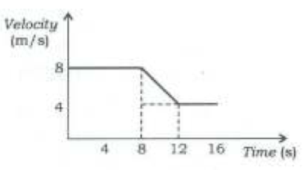
Which one of the following is the value of average acceleration from 8s to 12 s
- 8m/s²
- 12 m/s²
- 2m/s²
- -1m/s²
Q29 Which of the following graphs represent uniform motion: [NDA -2010 I]

- 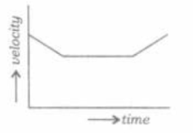
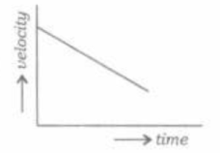

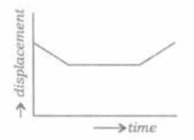

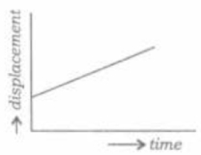
Q30 If two vectors and are at an angle ,then[CDS-2019]
Q31 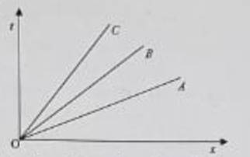
The figure shown above gives the time(t)vs position (x) graph of three objects A,B and C,then what is the correct relation between their speeds V_{A},V_{B} and V_{C} respectively at any instant t>0
[NDA -2019 I]
- V_{A}<V_{B}<V_{C}
- V_{A}>V_{B}>V_{C}
- V_{A}=V_{B}=V_{C}
- V_{A}=V_{B}=V_{C}=0

Q32
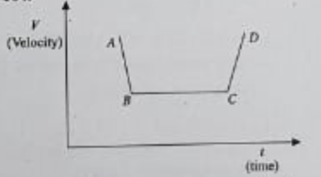
In the given Velocity(v) Vs time(t) graph accelerated and decelerated motions are respectively represented by line segments
[NDA -2019 I]

- CD and BC
- BC and AB
- CD and AB
- AB and CD

Q1 | Q2 | Q3 | Q4 | Q5
B | C | C | C | A
Q6 | Q7 | Q8 | Q9 | Q10
B | D | D | A | A
Q11 | Q12 | Q13 | Q14 | Q15
A | A | B | C | B
Q16 | Q17 | Q18 | Q19 | Q20
C | A | D | B | B
Q21 | Q22 | Q23 | Q24 | Q25
A | D | B | C | C
Q26 | Q27 | Q28 | Q29 | Q30
B | C | D | D | B

